**BANK LOAN REPORT QUERY DOCUMENT**

1. **BANK LOAN REPORT | SUMMARY**

**KPI’s:**

**Total Loan Applications**

select count(id) Total_Loan_Applications

from [Bank Loan DB]..bank_loan_data



**MTD Loan Applications**

select count(id) MTD_Total_Loan_Applications

from [Bank Loan DB]..bank_loan_data

where month(issue_date) = 12 and year(issue_date) = 2021



**PMTD Loan Applications**  
select count(id) PMTD_Total_Loan_Applications

from [Bank Loan DB]..bank_loan_data

where month(issue_date) = 11 and year(issue_date) = 2021



**Total Funded Amount**

SELECT SUM(loan_amount) AS Total_Funded_Amount

FROM bank_loan_data



**MTD Total Funded Amount**

select sum(loan_amount) as MTD_Total_Funded_Amount

from [Bank Loan DB]..bank_loan_data

where month(issue_date) = 12 and year(issue_date) = 2021



**PMTD Total Funded Amount**

select sum(loan_amount) as PMTD_Total_Funded_Amount

from [Bank Loan DB]..bank_loan_data

where month(issue_date) = 11 and year(issue_date) = 2021



**Total Amount Received**

select sum(total_payment) as Total_Amount_Received

from [Bank Loan DB]..bank_loan_data



**MTD Total Amount Received**

select sum(total_payment) as MTD_Total_Amount_Received

from [Bank Loan DB]..bank_loan_data

where month(issue_date) = 12 and year(issue_date) = 2021



**PMTD Total Amount Received**

select sum(total_payment) as PMTD_Total_Amount_Received

from [Bank Loan DB]..bank_loan_data

where month(issue_date) = 11 and year(issue_date) = 2021



**Average Interest Rate**

select round(avg(int_rate),4)*100 as Avg_Interst_Rate

from [Bank Loan DB]..bank_loan_data



**MTD Average Interest**

select round(avg(int_rate),4)*100 as MTD_Avg_Interst_Rate

from [Bank Loan DB]..bank_loan_data

where month(issue_date) = 12 and year(issue_date) = 2021



**PMTD Average Interest**

select round(avg(int_rate),4)*100 as MTD_Avg_Interst_Rate

from [Bank Loan DB]..bank_loan_data

where month(issue_date) = 11 and year(issue_date) = 2021



**Avg DTI**

select round(avg(dti),4)*100 as Avg_DTI

from [Bank Loan DB]..bank_loan_data



**MTD Avg DTI**

select round(avg(dti),4)*100 as MTD_Avg_DTI

from [Bank Loan DB]..bank_loan_data

where month(issue_date) =12 and year(issue_date) =2021



**PMTD Avg DTI**

select round(avg(dti),4)*100 as PMTD_Avg_DTI

from [Bank Loan DB]..bank_loan_data

where month(issue_date) =11 and year(issue_date) =2021



**GOOD LOAN ISSUED**

**Good Loan Percentage**

select (count

(case

when loan_status = 'Fully Paid' or loan_status = 'Current'

then id END)*100.0)

/count(id) as Good_Loan_Percentage

from [Bank Loan DB]..bank_loan_data



**Good Loan Applications**

select count(id) as Good_Loan_Applications

from [Bank Loan DB]..bank_loan_data

where loan_status = 'Fully Paid' or loan_status ='Current'



**Good Loan Funded Amount**

select SUM(loan_amount) as Good_Loan_Funded_amount

from [Bank Loan DB]..bank_loan_data

where loan_status = 'Fully Paid' or loan_status ='Current'



**Good Loan Amount Received**

select SUM(total_payment) as Good_Loan_Recived_amount

from [Bank Loan DB]..bank_loan_data

where loan_status = 'Fully Paid' or loan_status ='Current'



**BAD LOAN ISSUED**

**Bad Loan Percentage**

select(count

(case when loan_status = 'Charged Off' then id end)*100.0)/

count(id) AS Bad_Loan_Percentage

from [Bank Loan DB]..bank_loan_data



**Bad Loan Applications**

select count(id) as Bad_Loan_Applications

from [Bank Loan DB]..bank_loan_data

where loan_status = 'Charged Off'



**Bad Loan Funded Amount**

select sum(loan_amount) as Bad_Loan_amount_Funded

from [Bank Loan DB]..bank_loan_data

where loan_status = 'Charged Off'



**Bad Loan Amount Received**

select sum(total_payment) as Bad_Loan_amount_Recived

from [Bank Loan DB]..bank_loan_data

where loan_status = 'Charged Off'



**LOAN STATUS**

select loan_status,

COUNT(id) AS Total_Loan_applications,

SUM(total_payment) AS Total_Amount_Received,

SUM(loan_amount) AS Total_Funded_Amount,

AVG(int_rate * 100) AS Interest_Rate,

AVG(dti * 100) AS DTI

from [Bank Loan DB]..bank_loan_data

group by loan_status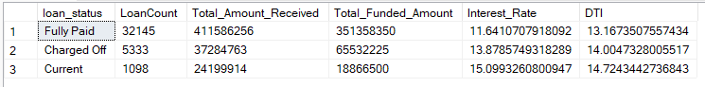

SELECT

loan_status,

SUM(total_payment) AS MTD_Total_Amount_Received,

SUM(loan_amount) AS MTD_Total_Funded_Amount

from [Bank Loan DB]..bank_loan_data

WHERE MONTH(issue_date) = 12

GROUP BY loan_status

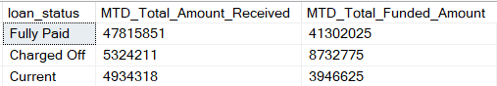

1. **BANK LOAN REPORT | OVERVIEW**

**MONTH**

select month(issue_date) as Month_Number,

datename(month, issue_date) as Month_Name,

count(id) as Total_Loan_Application,

sum(Loan_amount) as Total_Funded_Amount,

sum(total_payment) as Total_Receved_Amount

from [Bank Loan DB]..bank_loan_data

group by month(issue_date),datename(month, issue_date)

order by month(issue_date)

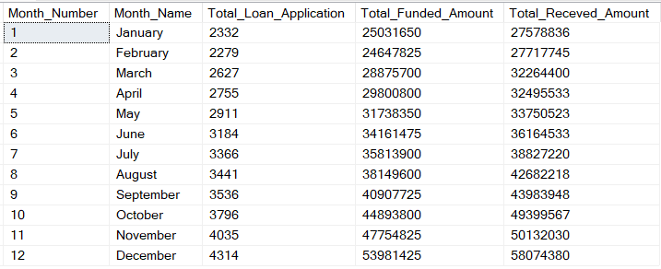

**STATE**

select address_state,

count(id) as Total_Loan_Application,

sum(Loan_amount) as Total_Funded_Amount,

sum(total_payment) as Total_Receved_Amount

from [Bank Loan DB]..bank_loan_data

group by address_state

order by address_state

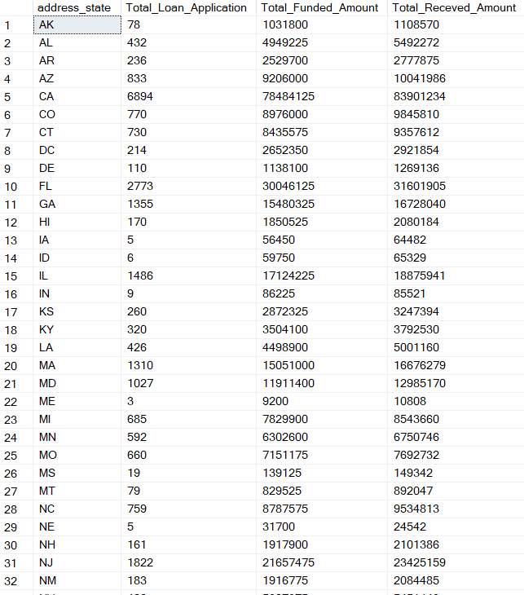

**TERM**

select term,

count(id) as Total_Loan_Application,

sum(Loan_amount) as Total_Funded_Amount,

sum(total_payment) as Total_Receved_Amount

from [Bank Loan DB]..bank_loan_data

group by term

order by term

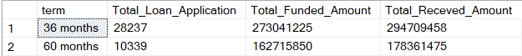

**EMPLOYEE LENGTH**

select emp_length,

count(id) as Total_Loan_Application,

sum(Loan_amount) as Total_Funded_Amount,

sum(total_payment) as Total_Receved_Amount

from [Bank Loan DB]..bank_loan_data

group by emp_length

order by count(id) desc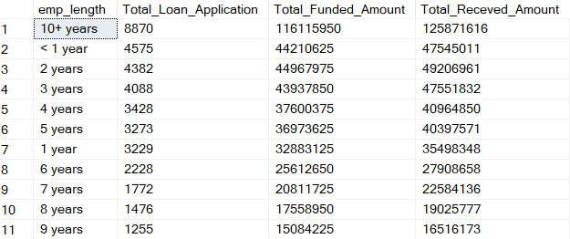

**PURPOSE**

select purpose AS Purpose,

count(id) as Total_Loan_Application,

sum(Loan_amount) as Total_Funded_Amount,

sum(total_payment) as Total_Receved_Amount

from [Bank Loan DB]..bank_loan_data

group by purpose

order by count(id) desc

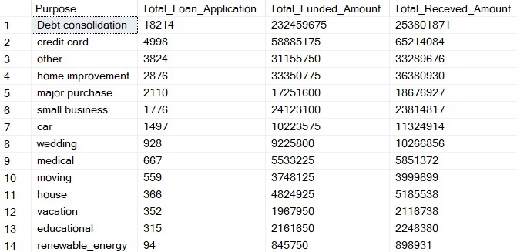

**HOME OWNERSHIP**

select home_ownership,

count(id) as Total_Loan_Application,

sum(Loan_amount) as Total_Funded_Amount,

sum(total_payment) as Total_Receved_Amount

from [Bank Loan DB]..bank_loan_data

group by home_ownership

order by count(id) desc

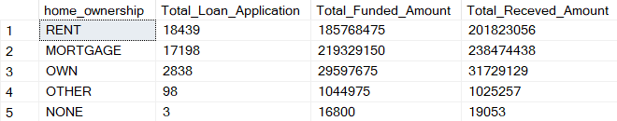

*Note: We have applied multiple Filters on all the dashboards. You can check the results for the filters as well by modifying the query and comparing the results.*

*For e.g*

*See the results when we hit the Grade A in the filters for dashboards.*

*select home_ownership,*

*count(id) as Total_Loan_Application,*

*sum(Loan_amount) as Total_Funded_Amount,*

*sum(total_payment) as Total_Receved_Amount*

*from [Bank Loan DB]..bank_loan_data*

*where grade = 'A' and address_state = 'CA'*

*group by home_ownership*

*order by count(id) desc*

